Course Project: Tiny Dragon
Members
We are:
- Võ Công Hiếu : DE181064
- Lê Văn Đạt : DE180983
- Tạ Tuấn Kỳ : DE180211
- Nguyễn Ngọc Anh Tài : DE180944
Story
Tiny Dragon is a Dragon Ball-inspired 2D action/platform game. The player controls DragonBoy250, a young fighter who moves through tutorial and combat stages, learns basic actions, manages HP/KI, defeats normal enemies, and fights an Act 1 boss. The game keeps progress through SQLite save data so player state can be restored across scenes.
Game Design
How many characters are there in the game?
There are 3 main gameplay character groups:
- Main character: DragonBoy250, controlled by the player.
- Normal enemy: spawned into the level for patrol and combat encounters.
- Act 1 boss: stronger enemy with chase, slash, energy blast, and combo attacks.
Supporting gameplay objects include player projectile, boss projectile, floating damage text, HUD, inventory panel, tutorial UI, intro/menu, and game over UI.
How many scenes are there in the game?
There are 4 enabled scenes in the build settings, shown below as actual Main Camera captures rather than separate asset previews:
- Intro: Story intro scene rendered from Main Camera.
- Level_01_Original: Original first screen/level rendered from Main Camera.
- Level_01_guide: Tutorial gameplay level rendered from Main Camera.
- Level_02: Second combat/boss level rendered from Main Camera.
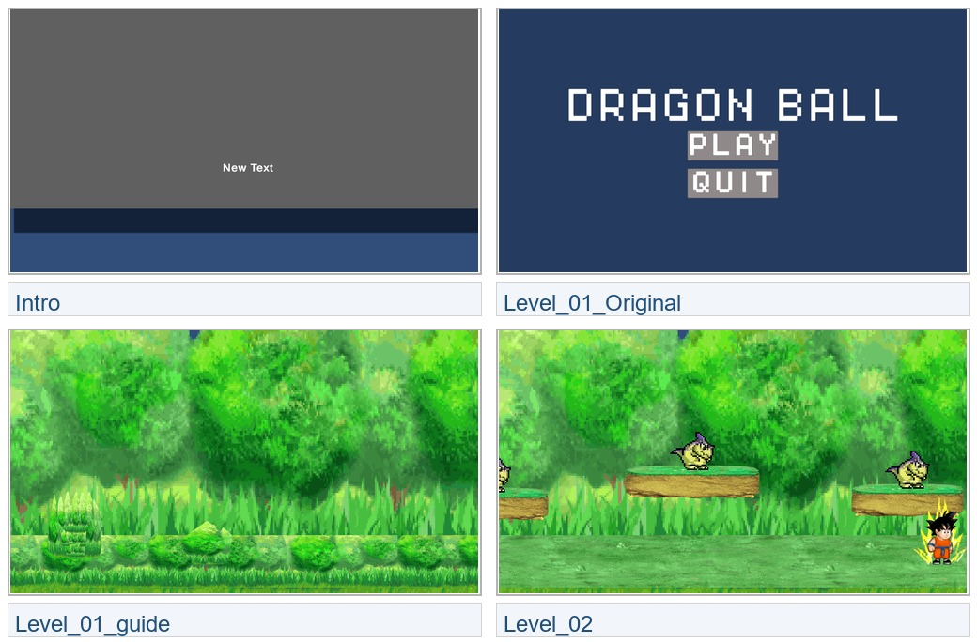
Main Camera captures for the 4 enabled scenes.

Intro - captured from the scene Main Camera.
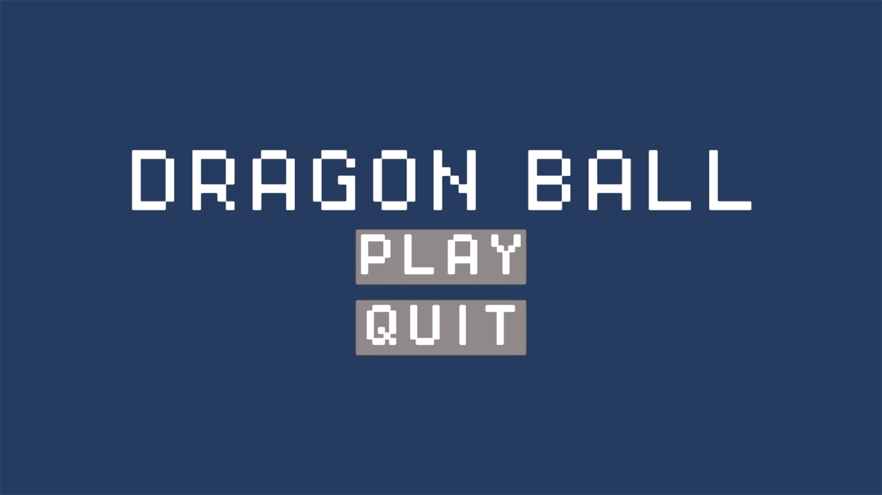
Level_01_Original - captured from the scene Main Camera.
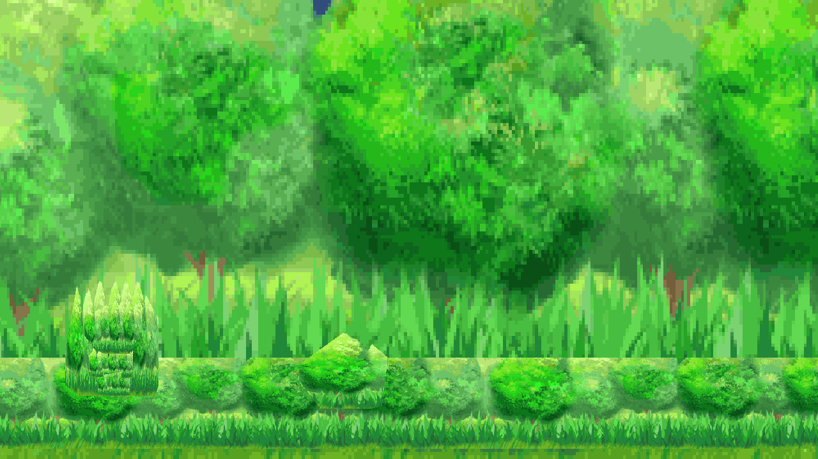
Level_01_guide - captured from the scene Main Camera.
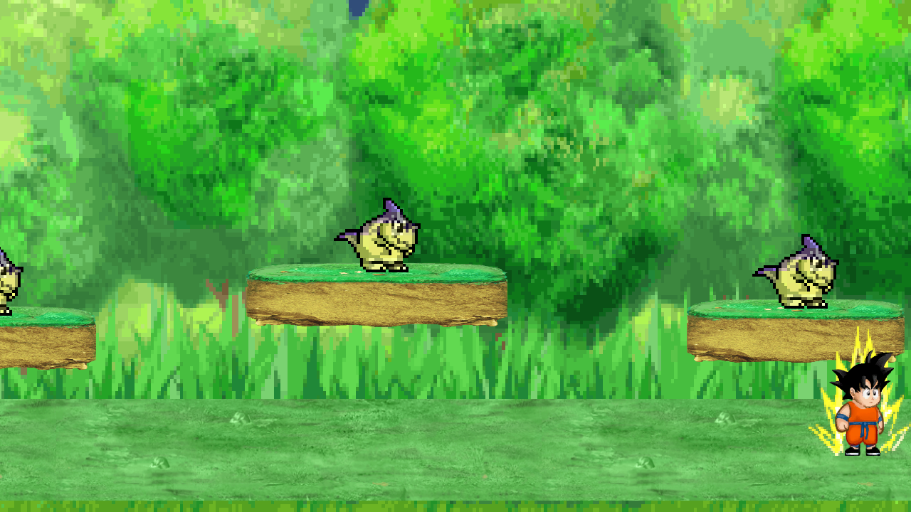
Level_02 - captured from the scene Main Camera.
How is each character?
- DragonBoy250 can move, jump, attack, use Power Shot, open inventory, transition scenes, take damage, die, retry, and restore saved HP/KI/stat state.
- Normal enemies are spawned by EnemySpawner, use health/damage balance data, and provide the basic combat loop before the boss fight.
- The Act 1 boss detects the player, chases, turns toward the player, uses melee slash, ranged energy blast, combo attack, and animation fallback states.
Sprites
Sprites are represented in the report through Main Camera gameplay screenshots. The scene captures above show how the menu, player, enemy, platforms, background, and gameplay sprites appear in the actual camera view. The project sprite source folder currently contains 54 PNG files under Assets/_Project/Art/Sprites.
Sprite 1 - Player Body
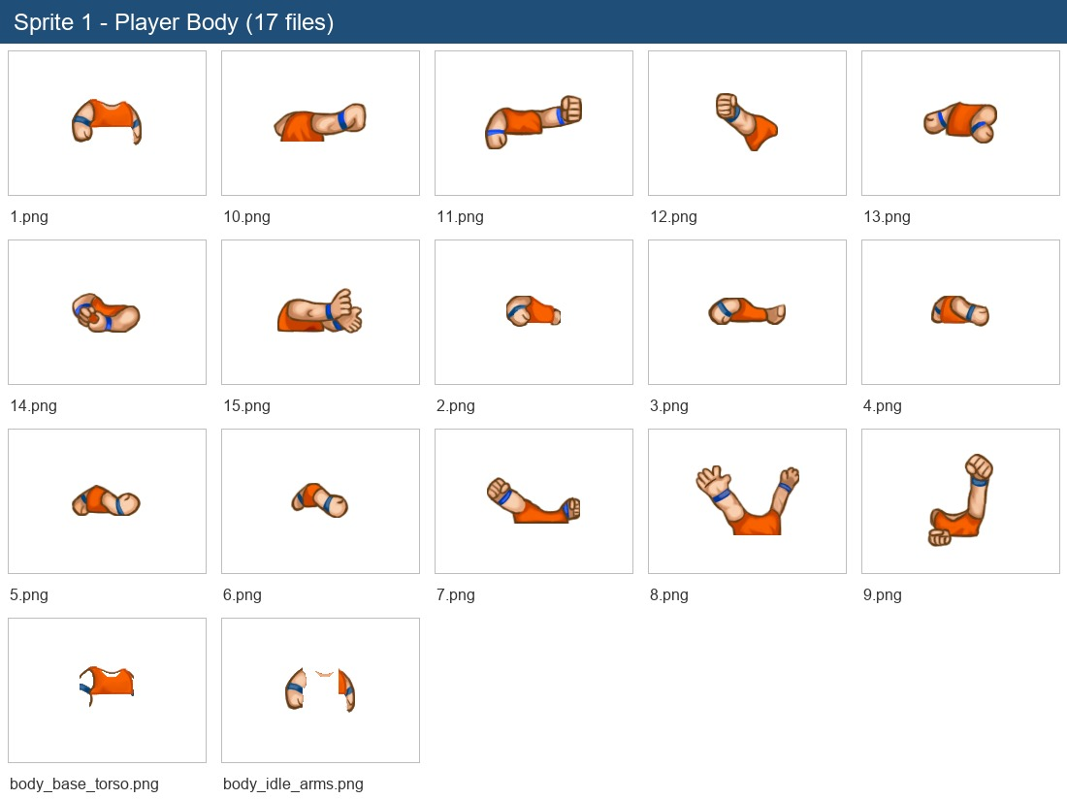
17 sprite file(s) from Sprite 1 - Player Body.
Sprite 2 - Player Head
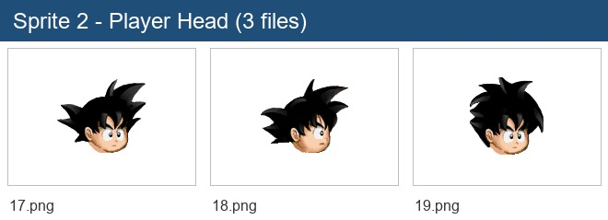
3 sprite file(s) from Sprite 2 - Player Head.
Sprite 3 - Player Legs
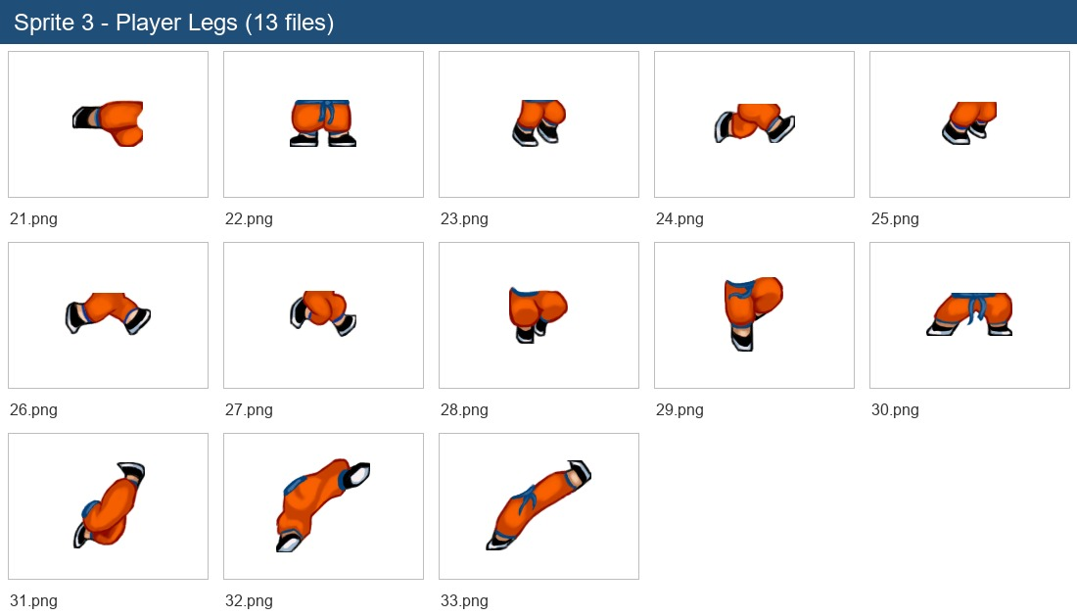
13 sprite file(s) from Sprite 3 - Player Legs.
Sprite 4 - Player Effects
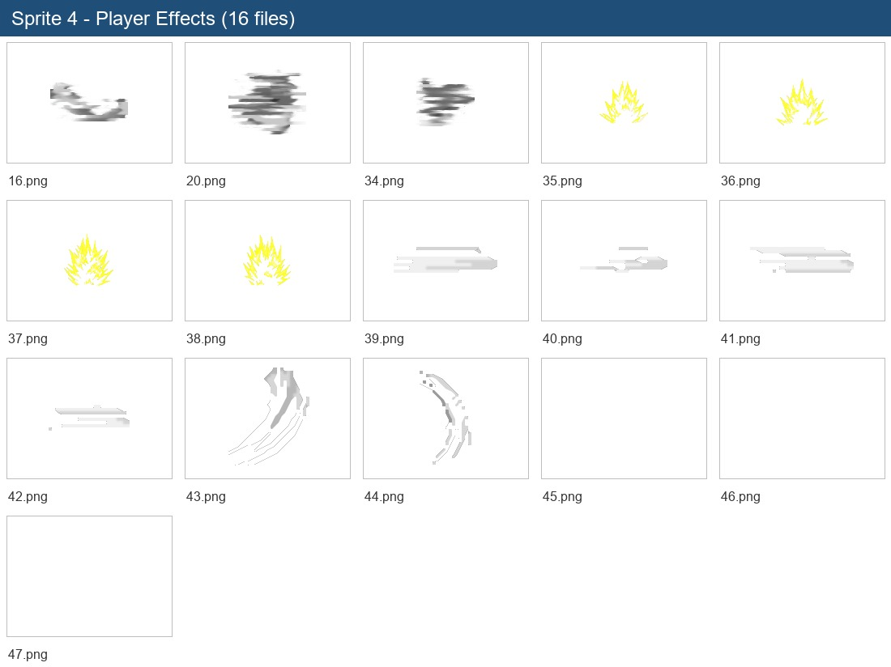
16 sprite file(s) from Sprite 4 - Player Effects.
Sprite 5 - Enemies
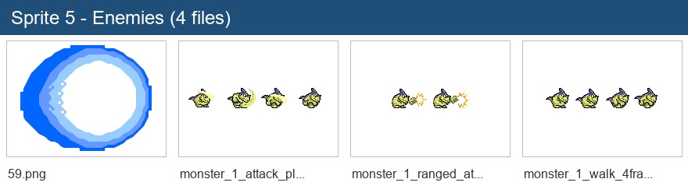
4 sprite file(s) from Sprite 5 - Enemies.
Sprite 6 - Boss / Projectile
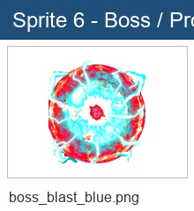
1 sprite file(s) from Sprite 6 - Boss / Projectile.
Game development: Requirements
Requirement 1
The character is moved using keyboard input: Horizontal axis plus Left Arrow and Right Arrow fallback.
Requirement 2
The player can jump with Space/W/jump input when grounded.
Requirement 3
The player can attack with J using animation, sound, and projectile shooting.
Requirement 4
The player can use Power Shot with K. It consumes KI/mana, has cooldown, and fires a stronger projectile.
Requirement 5
Enemies and boss can damage the player. Player projectiles can damage enemies.
Requirement 6
The game has HP/KI HUD, inventory panel, and game over/retry flow.
Requirement 7
The player can move between Level_01_guide and Level_02 through scene transition boundaries.
Requirement 8
The project includes Intro, Level_01_Original, Level_01_guide, and Level_02 in build settings.
Game development: extra functions
Extra function 1
SQLite save/load system stores player scene, position, facing direction, HP, KI, currencies, and inventory data.
Extra function 2
Inventory/stat system applies equipment bonuses to HP, KI, attack, defense, speed, and projectile damage.
Extra function 3
TutorialManager controls each tutorial step and can enable or disable movement, jump, attack, power shot, inventory, and custom actions.
Extra function 4
EnemySpawner can spawn normal enemies, limit active enemies, disable respawn in Level_02, and spawn the boss after normal enemies are defeated.
Extra function 5
BossAI supports chase, facing direction, melee slash, energy blast, combo attack, animation fallback, and debug ranges.
Extra function 6
Projectile and damage popup pooling reduce runtime object creation.
Extra function 7
Generated tile progress is present with EarthTileSet and 345 generated Tile_*.asset files.
Future works
The functions that are planned or still need more polish:
- Balance HP, KI, attack damage, cooldowns, rewards, and Level_02 pacing after playtesting.
- Add more stages, enemy types, boss phases, items, and active skills.
- Improve save/load UI and inventory equipment interactions.
- Polish Main Camera composition, animations, sound effects, tutorial text, and final tile set organization.
Appendix
1. Github: https://github.com/Peaker04/Tiny-Dragon.git
2. Engine: Unity 6000.4.6f1
3. Current branch/head: dev at 39d9b22
4. Build scenes: Intro, Level_01_Original, Level_01_guide, Level_02
5. Contribution:
- conghieu: 24%
- Datlee: 24%
- PeakerOJT: 28%
- Nguyễn Ngọc Anh Tài / Tai: 24%

